
FÉDÉRATION INTERNATIONALE dE PHILATÉLIE

Section for Astrophilately

Chairman: Igor RODIN Secretary: Jaromir MATEJKA

P.O. BOX: 972 Laxenburgerstrasse 87

MOSCOW, 101000, RUSSIA 1100 WIEN, AUSTRIA

TEL/FAX: 007 499 740 75 95 FAX: 0043 1 6029895

e-mail: igrtsermf@mail.ru E-MAIL: miri.matejka@chello.at

MINUTES of the BUREAU MEETING.

LISBON, October 8, 2010.

Participants:
Mr. I.Rodin, Chairman
Mr. J.Matejka, Secretary
Mr. C.Bromser, Bureau member
Mr. R.Todd, FIP Coordinator for Astrophilately
Mr. S.Reinhard, Chairman of the FIP Commission for Aerophilately

1) Welcome to members.
Chairman, Igor Rodin opened the Bureau Meeting at 08:00 a.m. He welcomed the participants and presented apologizes for absence received from Mr. R.Ramkissoon and Mr. J.Cacka who were unable to attend the meeting.

2) Approval of the Minutes of the Bureau Meeting held in Bucharest on the 26th of June 2008.
The participants approved the minutes prepared by the previous Secretary of the Section Mr. Lafon without any comments.

3) Acceptance of the report on activities 2008 – 2010.
The report was approved without any comments.

4) Report on activities of the Chairman and the Bureau members.
Nothing was added to the report on activities 2008 – 2010.

5) Proposal for future projects and plans.
Igor Rodin reported about the plans of the Section for the period of 2010 – 2012. Mr. R.Todd told about the necessity to prepare a promoting program for the next 2 years. Mr. Rodin agreed with the necessity of preparing such a program.

6) Venue for the next meeting.
The venue for the next Bureau Meeting will be defined later in according to the decision about the venue for the 72nd FIP Congress.

The Meeting was closed at 08:30 a.m.
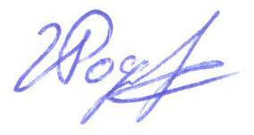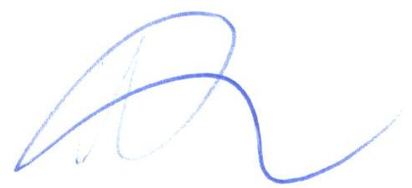

Igor RODIN Jaromir MATEJKA
Chairman Secretary

